Cold War 2 – Hero List

Cornelius Columbo - Jonathan Goldsmith
The elder in the Columbo family, 45, a military commander for the Marines who fought in the War on Terror. He is constantly aware of the trouble in other nations and has a hunch about world war 3. (no one takes him seriously). He is the smartest in the family and he has a manner about him that has most peers in awe. He always wears nice suits and keeps his children by his side to teach them how to be like him and carry on the family legacy.
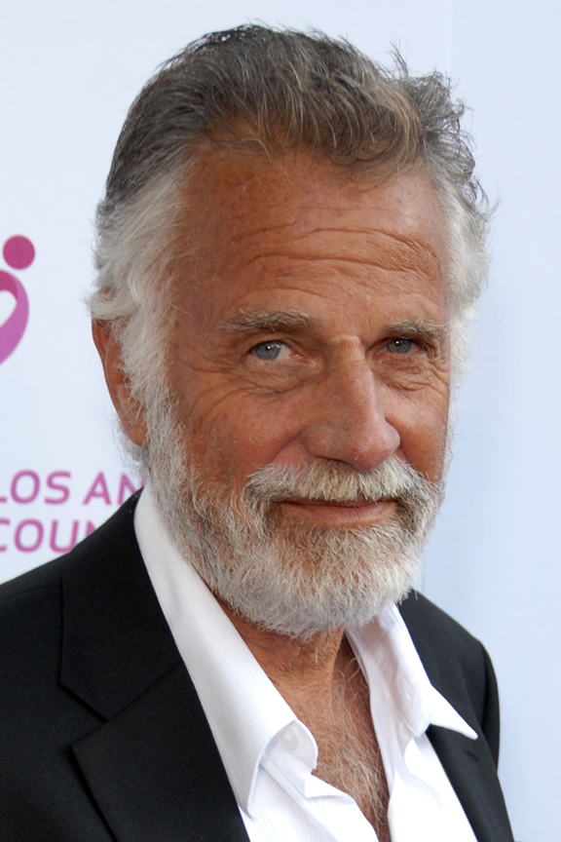

Christopher Columbo - Michael Peña
A young man, 19 years of age, trained to be a marine like his father and he is sent by the US Government to highjack a Russian Arms ship that is headed for the moon. He is young but a skilled commander and he has been schooled in every language. Takes on the mission and successfully defeats the enemies yet he sacrifices himself to blow up the moon and save the world from the tyranical rule of the Russian mafia. He grows as the movie goes on.


